RM of Prairie Lakes
https://www.rmofprairielakes.ca/

Self-Guided Tour #5

Dunrea & Nearby

For the online version and additional information, visit:

www.virtualmanitoba.com/prairielakes/

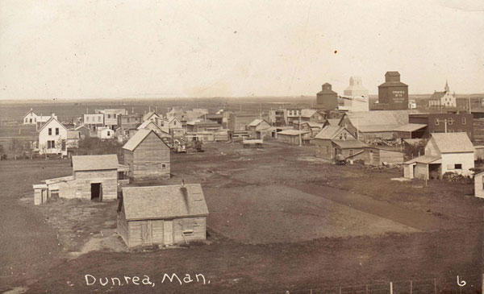

With the arrival of the railway, the village of Dunrea was located on land owned by John Dunlop and Thomas Rae, and thus the name was created. There had been a small hamlet west of town where the original St. Felix Church was located, and a few of Dunrea’s first buildings were moved from that site. It soon became a busy town.

As you drive into town from Highway #23 this impressive statue in a well-tended park is one of the first sites to see.

1.Cabrea the Snow Goose

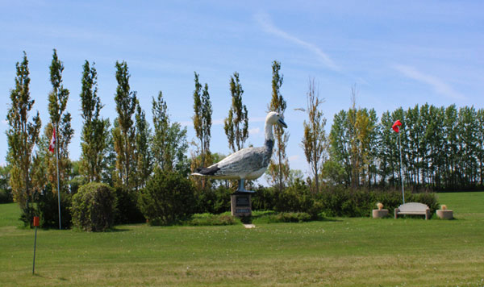

Cabrea was erected in 2000 to recognize the location along the migration flyway of this iconic northern bird.

2. The Dunrea Hotel

Also to your left is the Hotel, built by the Malliot family in 1965.

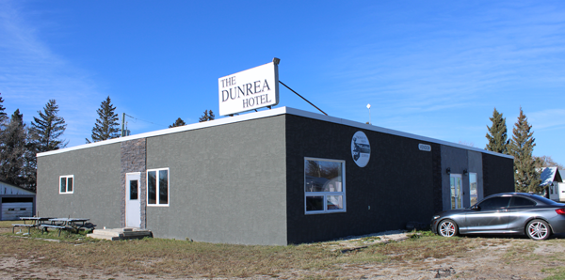

3. Commercial Sites

As you proceed northwards you will pass the remnants of a once bustling downtown.

Lavoie’s Store – later the Solo Store – was built in 1914.

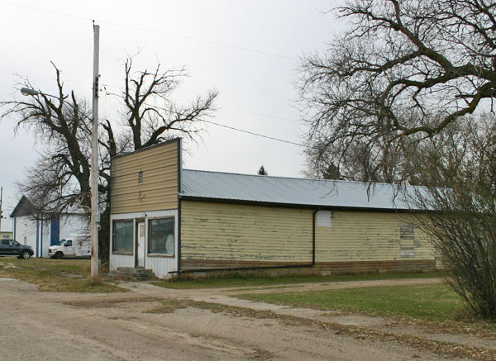

The modest Dunrea Credit Union Building, long closed, is still in place.

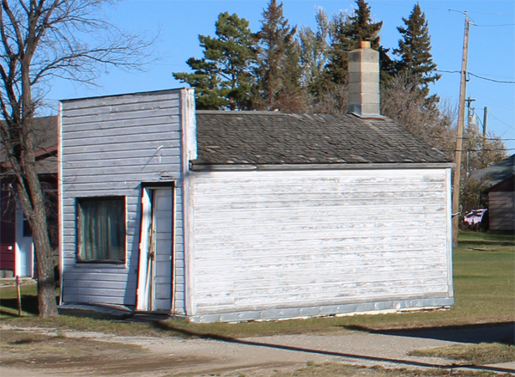

The Credit Union was formed in 1943 as a sub-branch of the Killarney Credit Union.
The first office was in the Post Office building. In 1947 this building was built and it was used until 1991.

As you pass the former “downtown” you will see an open grassy area. This is where the railway line divided the town in half. Along this space there used to be a station, elevators and other railway related buildings.

4. Elevators

Dunrea has had five elevators over the years.

Ogilvie Flour Mills was 1899
Young Grain Co, 1899
Northern Elevator Co. 1893
Manitoba Elevator Commission 1911
Pool Elevator 1928

5. The Dunrea School / Municipal Office
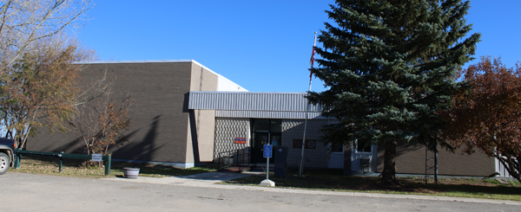

In the southeast corner of town, you will see the former school. Later used as a Municipal Office. The School District was originally called Albion when established in1883. The name lasted until 1966. This building replaced an earlier two-story structure.

6. 10. St. Felix de Valois Roman Catholic Church

St. Felix will be easily spotted in the northwest corner of the village.

The first St. Felix Church was a small frame building built in about 1891, southwest of where the village was later located. This Church was built in 1903.

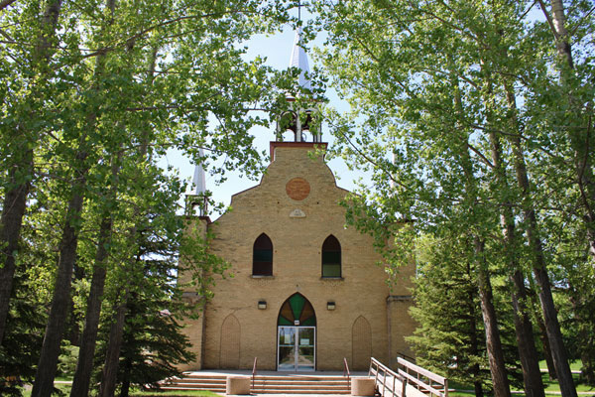

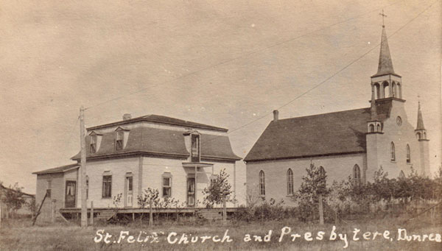

Some Nearby Sites

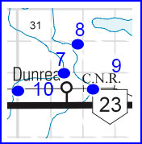

7. Dunrea Protestant Cemetery / Rea Cemetery

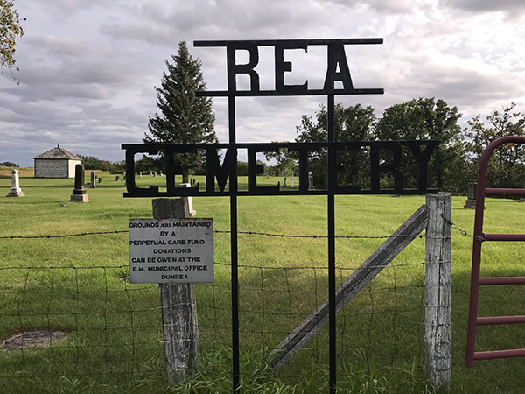

The Protestant Cemetery, often called the Rea Cemetery, was established in the early Pioneer Era on SE 29-5-17. The first burial occurred in 1882.

N 49.41431, W 99.72666

8. The Dunlop Cemetery

The first burial in this private cemetery, created by the Dunlop family, occurred in 1910.
N 49.42650, W 99.72447

9. The CN Railway Bridge

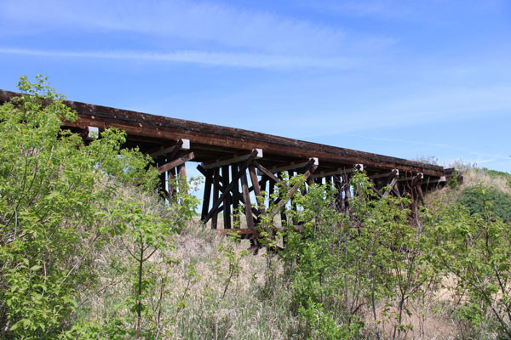

A short walk on a rough trail east of Dunrea takes you to this fine old railway bridge.

N 49.407072 W 99. 717673

10. St. Felix de Valois Roman Catholic Cemetery

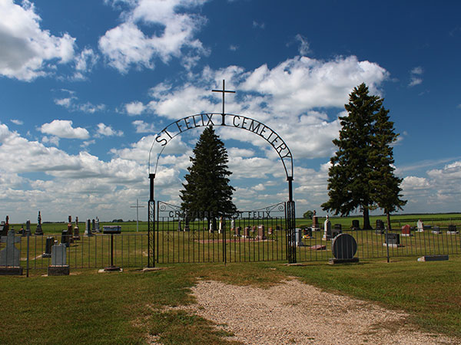

The Catholic Cemetery is just west of the village. It is on land donated by Joseph Fortier – the first burial was in 1907.

N 49.40660, W 99.74355

