RM of Prairie Lakes
https://www.rmofprairielakes.ca/

Self-Guided Tour #4

Ninette Area

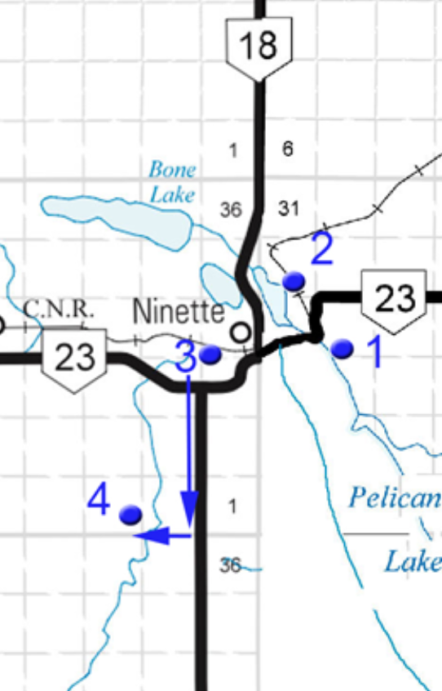
For the online version and additional information, visit:

www.virtualmanitoba.com/prairielakes/

1. The Sanatorium

As you approach Ninette from the east along Highway #23, the first thing you will notice is the panoramic view.

On the south side of the Highway is the former Ninette Sanatorium.

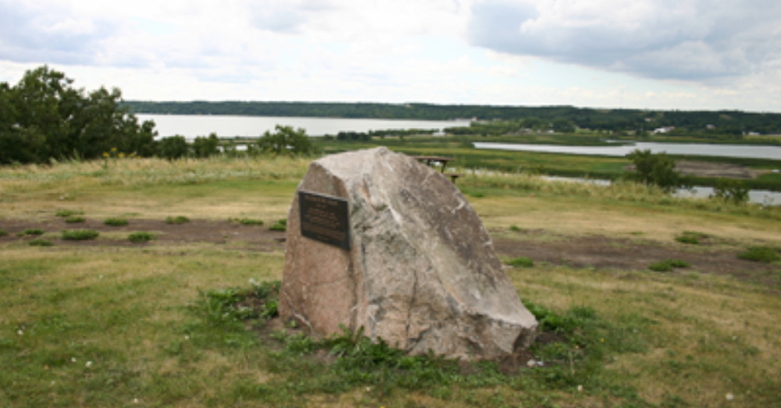

Just off of the Highway to the north is the attractively situated “Healers In The Valley” Monument commemorating the work of Dr. Alfred Paine and his wife, Teddy Paine, a Registered Nurse.

The former San buildings are across the highway to the south.
The Sanatorium Board of Manitoba operated several tuberculosis sanitoria in Manitoba from the early 1900s until the 1960s.
The facility was largest sanatorium in the province, comprising over a dozen buildings.

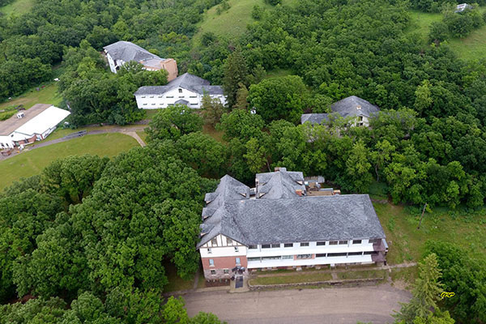

Aerial view of the Ninette Sanatorium site (July 2019). Source: George Penner.

The facility closed in 1972. From 1973 to 2000, it operated as the Pelican Lake Training Centre, then as a Christian conference centre and retreat. A monument near the former administration building commemorates Dr. Stewart, the first Superintendent of the facility. He is also noted on a historical marker erected at the site by the Historic Sites Advisory Board of Manitoba.

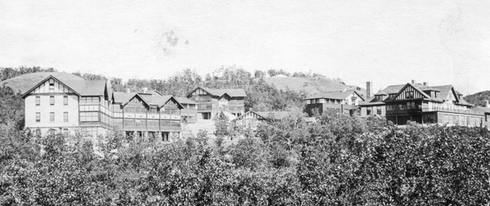

2. The Strathcona Trail

Across from the San on Highway #23, to the north you might catch a glimpse of the abandoned railway bridge that is now part of the Strathcona Trail.

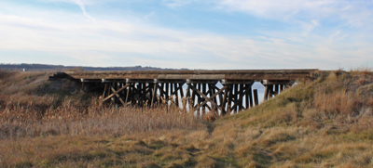

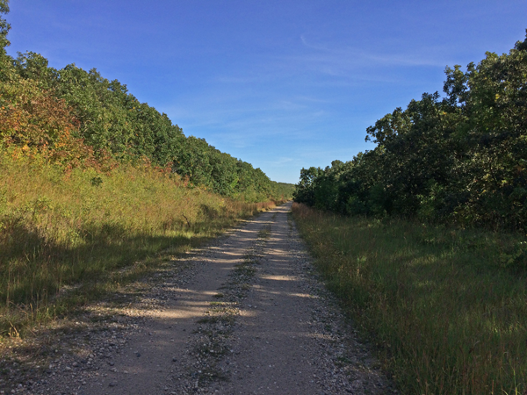
The trail climbs gently out of the valley. Railways avoided steep grades.

3. Ninette Cemetery

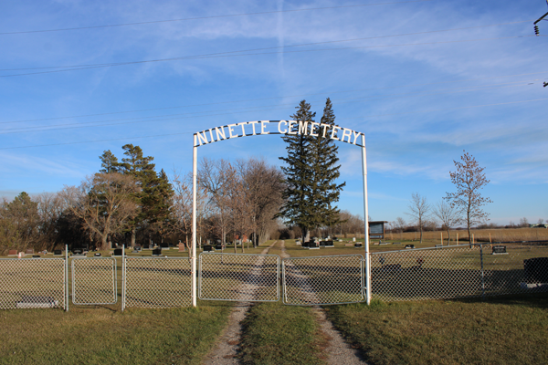

As you exit town to the south along Highway #23&18, across from the Ninette Motor Hotel you can leave the highway to the right and take a scenic gravel road up the hill to the Cemetery. (It is also accessible from the first right turn as the highway crests the hill.
The land for the Cemetery was sold by Charles Overend for $1 in 1922, but the first recorded burial was in 1916. Other earlier burials involved graves moved from other locations. Records are missing because the safe containing them was stolen and the contents destroyed. Some patients from the Ninette Sanatorium were buried here.

N 49.39886, W 99.64244

4.Knox Bellafield Church

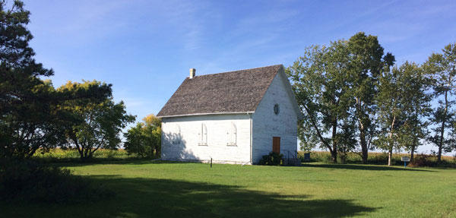

Knox Bellafield Presbyterian Church is situated roughly in the middle of what used to be known as the Crofter Settlement. Once known locally as the Gaelic Church, is a direct link to a group of Gaelic-speaking families, settlers from the Isles of Lewis and Harris in the Western Isles of Scotland.

N 49.35709, W 99.67603

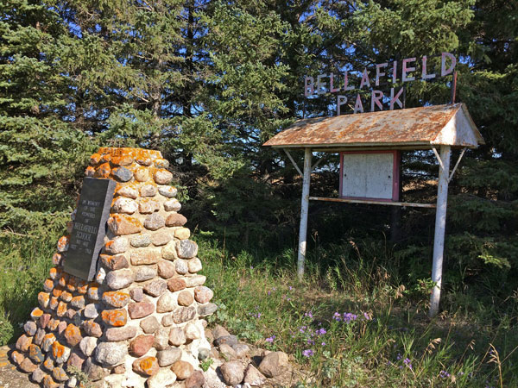

The Bellafield School was nearby along Highway #18. It was opened in 1884.
N 49.35471, W 99.65203

