RM of Prairie Lakes
https://www.rmofprairielakes.ca/

Self-Guided Tour #3

Ninette

For the online version and additional information, visit:

www.virtualmanitoba.com/prairielakes/

A walk down the Main Street…

Begin your tour of downtown Ninette at the intersection of Highway 23 and 18.

If you look eastward you can see the rail bed. If you’re up for a walk – go east to the Strathcona Trail.

On the west side of the street, at the corner, you see the former Overend Store.

1. The Railway Story

The Northern Pacific and Manitoba Railway arrived in 1899, creating the current village. The station and elevators became the lifeblood of the community.

The first Grain Elevator was the Winnipeg Grain Co. (1900) followed by the Northern Elevator Co. (1903) and the Patterson Elevator (ca.1919). Patterson’s was sold to the Manitoba Pool Elevator Co. in 1928.

Walking eastward you will pass the former Overend Store.
2. The Store

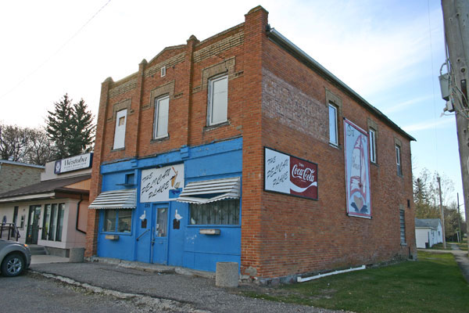

Built in 1908, this building was in continuous use as a store until recently. James Overend was the first owner.

The railway line crossed Highway 23 just to the north. The elevators and station were to the west on the other side of the tracks

3. Post Office Building.

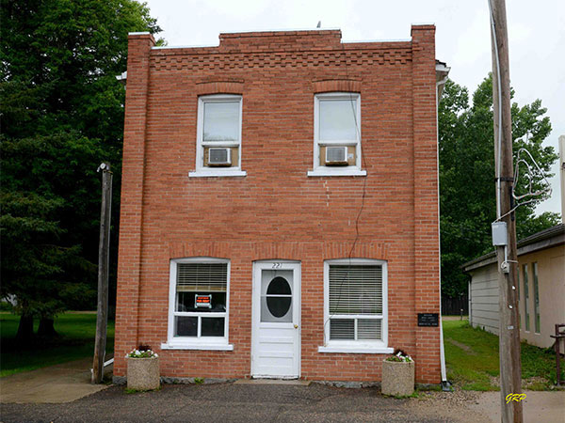

The first Ninette Post Office was located on the homestead of Thomas Colpitts in 1884. This building was built by Postmaster James Overend in 1911 and served until 1959.

A bit south, on the east side of the street you will see….

4. The Overend Hall

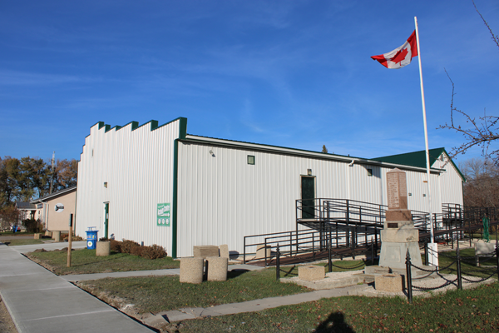

The hall was built in 1905 on the west side of Queens Street. The Legion bought the building and moved it to the east side in 1954. As you may have noticed, the Overend family were prominent in the early history of the region.

5. War Memorial

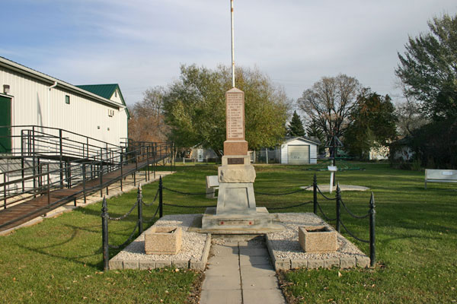

The Cenotaph was originally erected on Riverside Street and moved to the Hall after the Legion took it over.

In the west side of town…

6. Ninette School

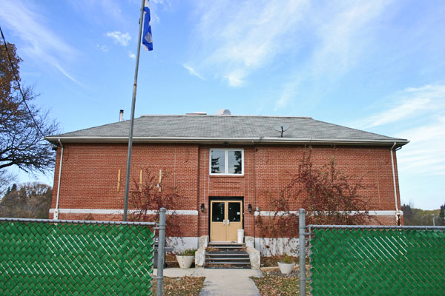
The Ninette School District was organized in 1899 and, for a time, students attended classes above a general store. In 1901, a one-story, one-classroom school building was erected around 1912.

This red brick structure was built in 1926.

The school closed in June 2007. The school building has been renovated into a private residence.
7. St. Michael’s Anglican Church

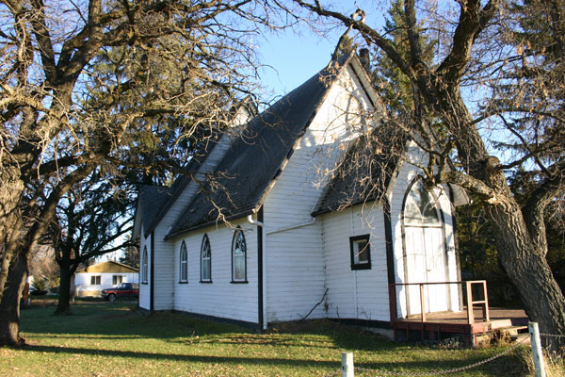

Beginning in 1903, Anglican services were held in the village school and soon the congregation began fundraising for this building.
8. St. Andrew’s United Church

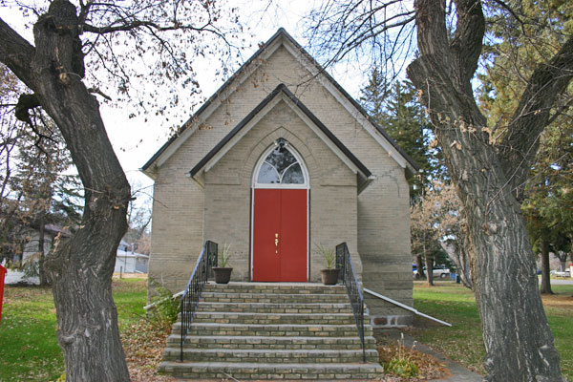
The United Church was build as a Presbyterian Church in 1908. At first the Church was used by Methodists as well. The two joined long before Church Union in 1925.
If you follow the Main Street south towards the lake you come to the Yacht Club and Terry Fox Park.
9. Pelican Lake Yacht Club

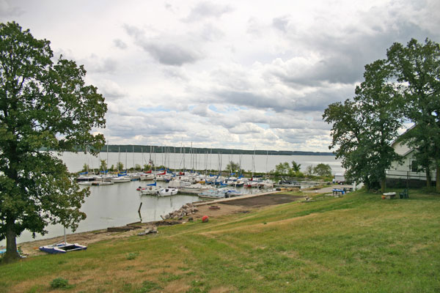

The Club was founded in 1965. The former Pelican Lake School was moved to the site in 1968 as a clubhouse.
10. Terry Fox Park

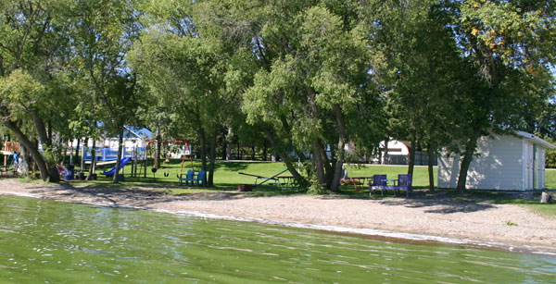

The Cairn, dedicated in 2004, tells the story of Terry Fox, whose maternal grandparents were from Ninette. Terry spent several summers here, and was baptized in the United Church Manse.

11. The Ninette Motor Hotel

Ninette’s first hotel was built in 1906. It was called the Christie Hotel. In about 1964 the Ninette Motor Hotel was opened.

