RM of Prairie Lakes
https://www.rmofprairielakes.ca/

Self-Guided Tour #2

Rural Sites near Belmont

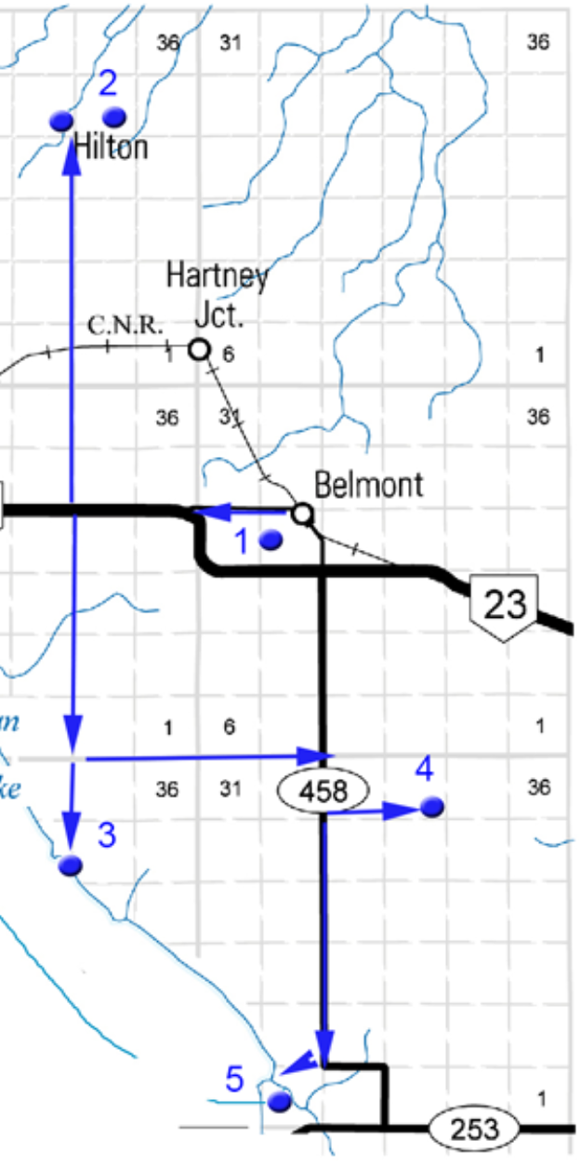

For the online version and additional information, visit:

www.virtualmanitoba.com/prairielakes/
1. Hillside Cemetery

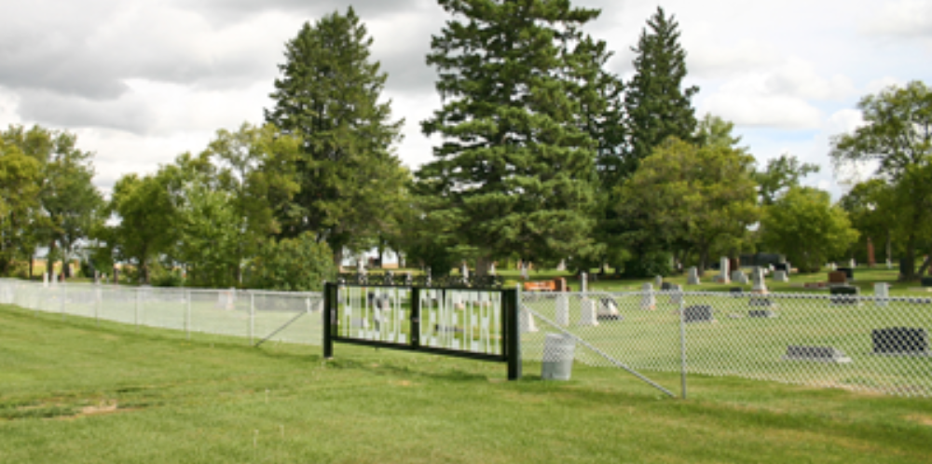
In 1893 Joseph Bell donated land for a community cemetery. In 1948 a newly formed Cemetery Committee organized a name contest. The winning entry was “Hillside Cemetery.

N49.40644, W99.47173

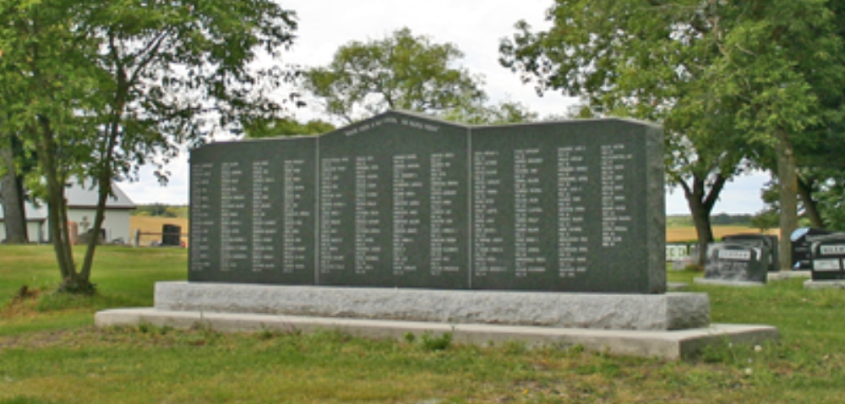

This monument commemorates the final resting place for the many patients from the Ninette Sanatorium.

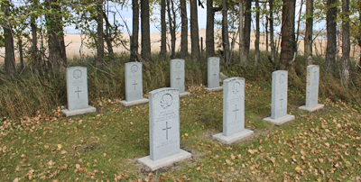

Note also the peaceful corner designated for the Military.

2. The Village of Hilton

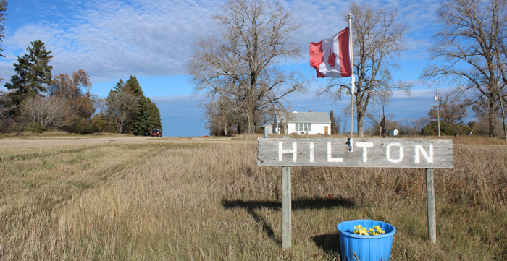

In 1889 the Northern Pacific and Manitoba Railway began constructing a line that began at Morris and ended in Brandon. Hilton was one of the many villages created along that line. By 1895 it had a population of 200 and a full range of rural village businesses.

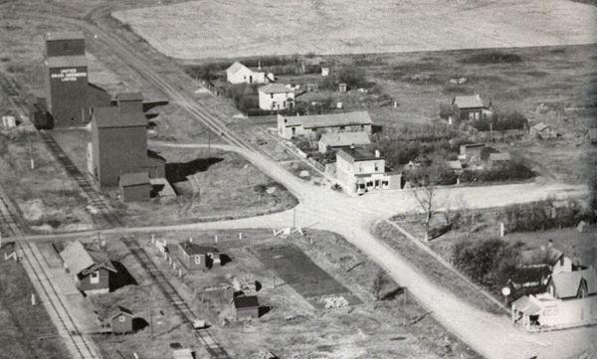

Note the small station - a lifeline to the rest of the world, and the two elevators – as vital economic presence.

As you stroll around the almost deserted village try to visualize the place as it once was.

Hilton United Church

This United Church, built in 1952, is a designated Municipal Heritage Site. It replaced an earlier Church that was destroyed by fire.

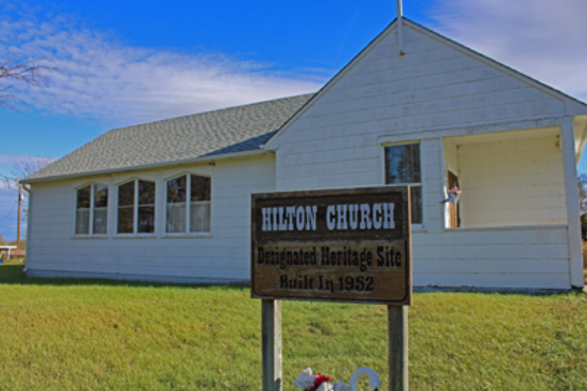

Hilton Pioneers Monument

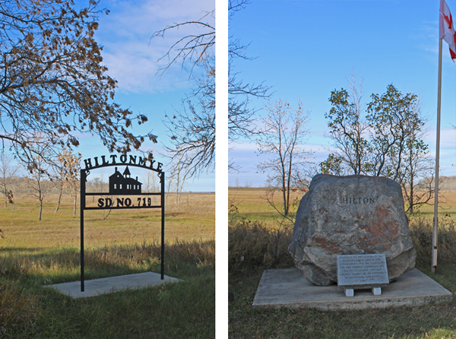

Monuments commemorating the Hiltonmye School and the Village were unveiled in 1987. The name Hilton was already taken by a school to the west that was opened before the village was created.

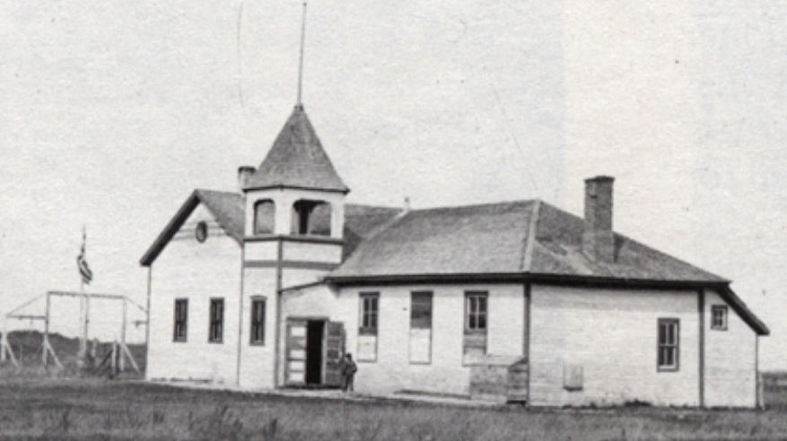
Hilton Cemetery

This cemetery is situated about a kilometre west of the village.

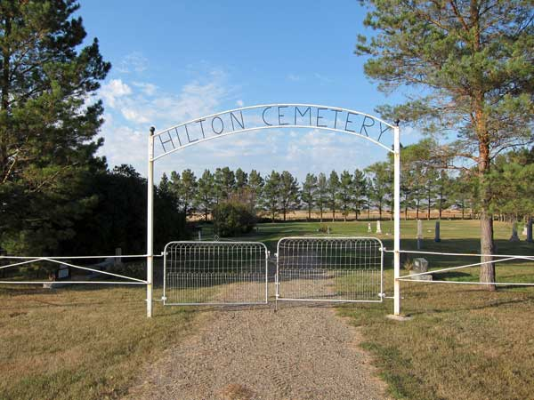

Is 1894 land on was donated by John and James Scott. The rows of Scotch Pines were planted in 1982.
N49.502823 W 99.541185

3. Y-Point / Strathcona Park

Strathcona Park, known locally as Y-Point, has long been a popular cottage development.

N 49.331322 W 99.548542

4. Alma School

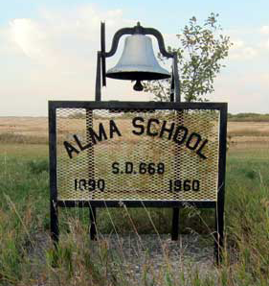

The School District of Alma, Number 668, was incorporated in 1889. The school, on land donated by Mr. Louis Cline Sr., was built with volunteer labor.

The first classes were held in 1890. The first teacher, Mr. Alex Tumoth, asked the students for suggestions for a name, and the name "Alma" was chosen.

In 1905, a new brick building, complete with bell tower, replaced the old school
Ths School was closed in 1960

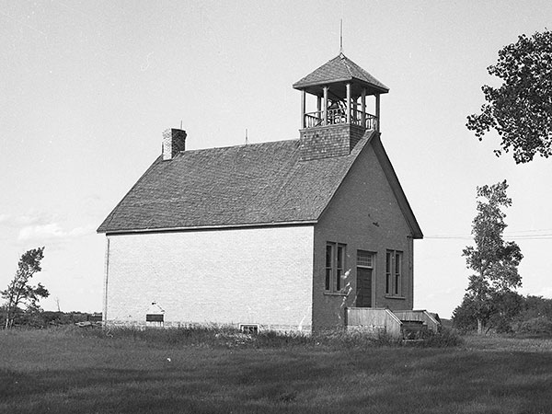

N 49.34068, W 99.41567

5. Pleasant Valley

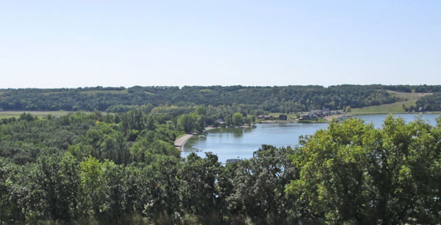

Pleasant Valley has been a popular spot for swimming, picnics, and camping since pioneer times. Today it is home to a fine Golf Course and modern cottage developments.

N 49.277845 W 99.469173

