RM of Prairie Lakes
https://www.rmofprairielakes.ca/

Self-Guided Tour #1

Belmont

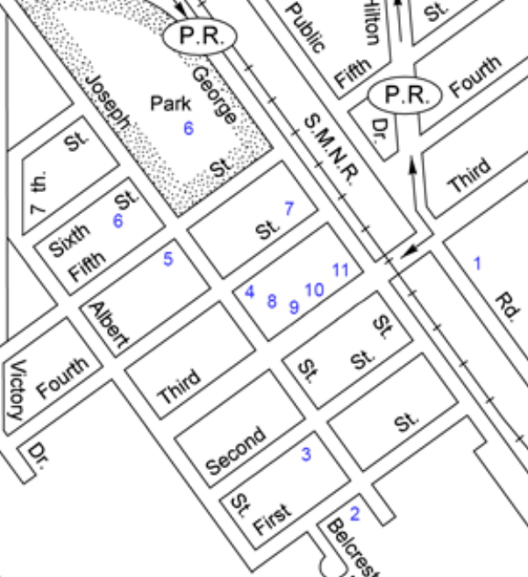

For the online version and additional information, visit:

www.virtualmanitoba.com/prairielakes/

1. The Railway

In 1889 the Northern Pacific and the Manitoba Railway began to build a branch line to serve the district from Morris to Brandon. A town site was chosen on a quarter section owned by Mr. John O. Bell. The land was purchased from Mr. Bell and in deference to this early pioneer, the town was named Bell's Mount.

Belmont was made a divisional point in 1899. A coal dock, water tank, depot with living quarters for the station agent, section house and roundhouse were all built that year. At that time there were approximately thirty-five railway men employed in Belmont.

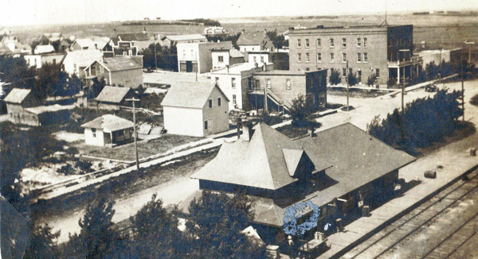

An elevator, purchased by United Grain Growers from Canadian Consolidated Grain in 1959 was destroyed by fire on 18 April 1973. Rebuilt as a 109,000-bushel elevator and crib annex in 1974, it was closed permanently in January 1999 and demolished in October 2000.

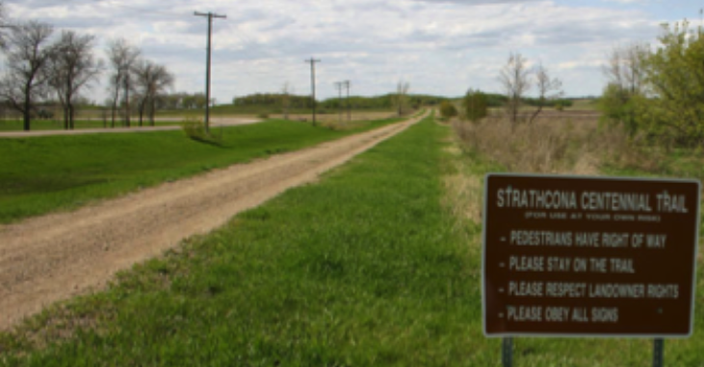

The old rail bed, running east of George Street was once the home to the station, elevators, water tower and roundhouse. It is now the Strathcona Trail, running all the way to Ninette.
2. Schools

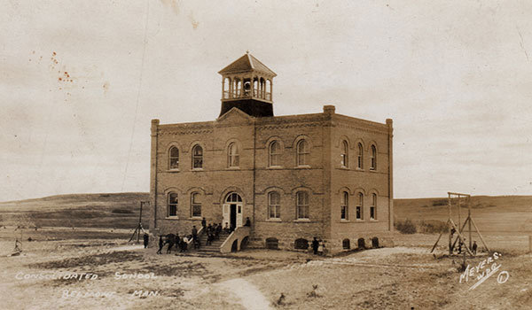

The first school district in the region, named Craigilea, was formed in 1886. The schoolhouse was moved onto the new town site of Belmont in 1890, and a four-roomed brick school was opened in 1904. A monument marks the site

3. Former Presbyterian / United Church

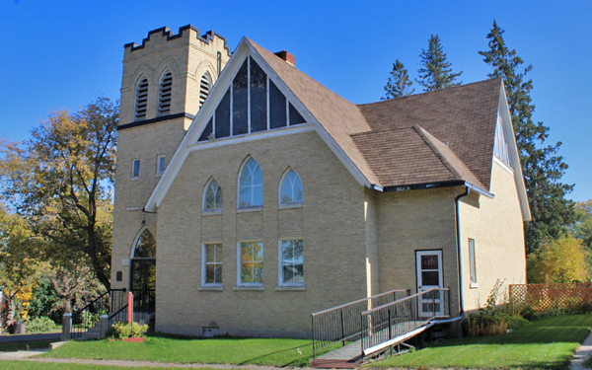

The Belmont United Church was built as a Presbyterian Church in 1901. Following Church Union in 1925 brick veneer was added. It closed in 1991 and is now privately owned.

4. Christ Church Anglican

This Anglican Church was built in 1901. Inside is a stained glass window commemorating local veterans of the First World War. Now deconsecrated, the building is operated as part of the Belmont and District Museum.

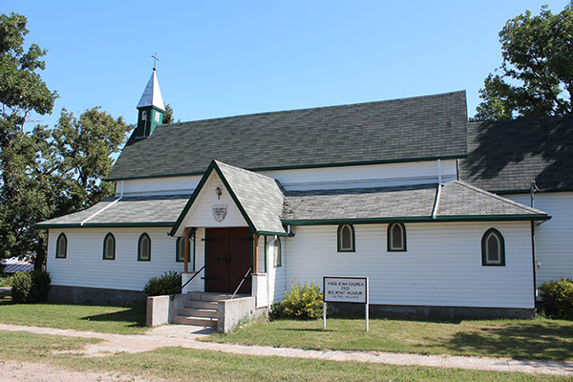

5. The Belmont and District Historical Museum

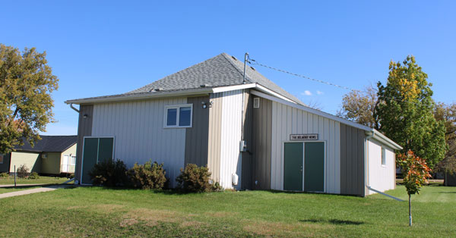

The museum is operated by the Belmont and District Historical Society. The railway caboose across the street is a part of the museum collections, along with printing equipment from the former Belmont News, medical equipment from the late Dr. Stevenson, military uniforms, and other artifacts.

6. The Sports Grounds & Arena

The Belmont Recreation Centre was built in 1974 by volunteer labour.

The Belmont A Team

In the summer of 1951, the Belmont A team was first organized into Official League Baseball. That year the team succeeded in getting into the finals of the Central Manitoba playdowns.
7. The Former Belmont News Building

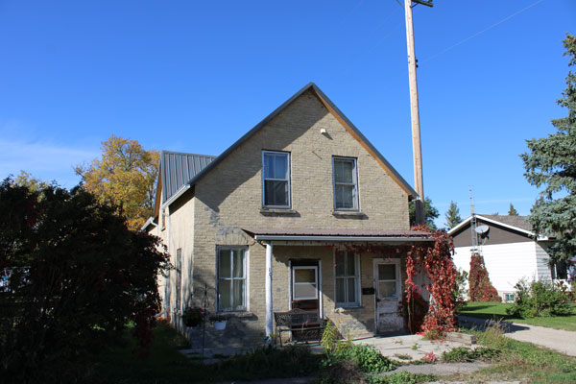

The first Belmont News arrived in 1903 and it was published until 1988. It was one of the last newspapers in Canada to publish using the traditional letter press and hot metal method. The local museum has an excellent display of the equipment they used.

8. The War Memorial

This monument was erected in 2005 to commemorate people from the local area who have served in military conflicts.

9. The Bank of Montreal Building

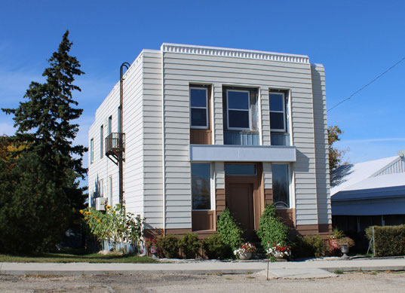

Belmont’s first three bank buildings were destroyed by fire before this structure was built in 1941.

10. Main Street

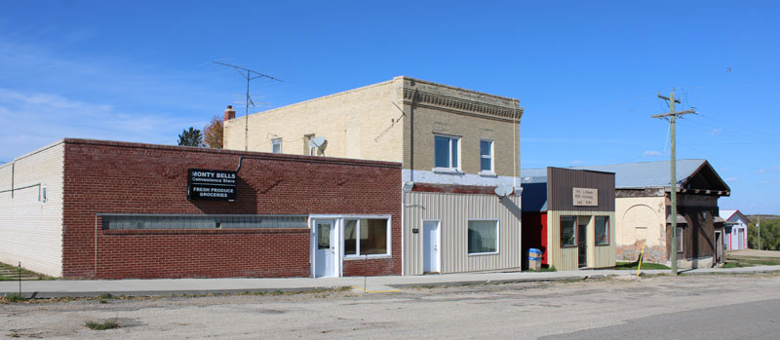

In 1941 J.W. Harrison bought the former McIntyre and Castell store (brick building in centre) and in 1946 expanded it into a “modern” Groceteria.

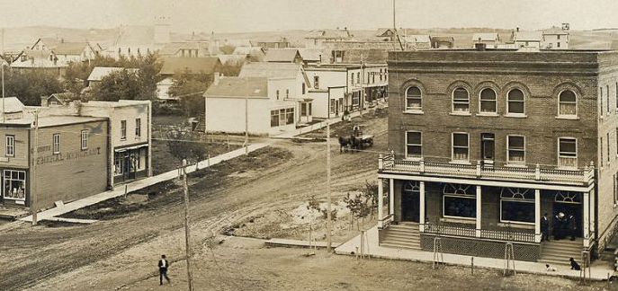

Downtown Belmont in about 1910.

11. The Hotel

The “Trafalgar" on Third and George Streets (see the photo above) was one of the best hotels in southern Manitoba, containing thirty-one rooms. This hotel had its own lighting plant, which also supplied power to the other businesses up the street.

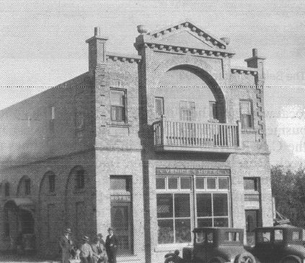

In 1919 it was destroyed by fire, and replaced by "The Venice Hotel". In 1970 The Belmont Motor Hotel was built on the foundations of the Venice Hotel.

