What am I? I live between Deloraine and Boissevain. I can look dry and weathered, or, fresh and sparkly. Muskrats, whooping cranes, explorers and hunters have enjoyed my hospitality. A village beside carries my name.

I’m Whitewater Lake. Locals just call me The Marsh. I am who I am.

Lately I've been causing trouble. I take on too much water. I've been spilling over farmers' land to the north. It's hard to imagine I can go totally dry - with windstorms taking my dust as far as Lake Manitoba. 1988 and the 30s were that way. Crazy to see people and animals walking across - like I'm a parking lot! 1913 was so dry surveyors were sent out, preparing to sell my bottom for $25 an acre. Well, that didn't impress me much.

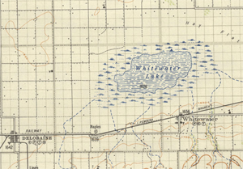

Most of my water comes from my buddy to the south, Turtle Mountain. I get a bit extra as farmers drain fields to get an early start in Spring. But when water gets to me, it has no place to go. Like the Dead Sea. Way back, just after the Ice Age, I would spill overland to my other buddy - the Souris River. Now, I depend on the sun to evaporate my water – which creates white, salty soil around me. Hence my name.

Humans have lived and hunted here for 10,000 years. I've watched them my whole life. There's a trail just south of me – called the Mandan. It's named after a nation of farmers whose ancestral home is on the Missouri River. This was their road to the Assiniboine River to trade with the Cree Nation. In summer I'd hear singing and drumming coming from up the hill a ways. Pure beauty.

In the early 1800s and for thousands of years before that, massive bison herds would drink from me. Grasslands to the north brought them around a few times a yeaur, and hunters followed - Dakota, Assiniboine and Metis. Metis hunters even set up winter settlements nearby. They got top dollar for soft winter hides. I enjoyed their company.

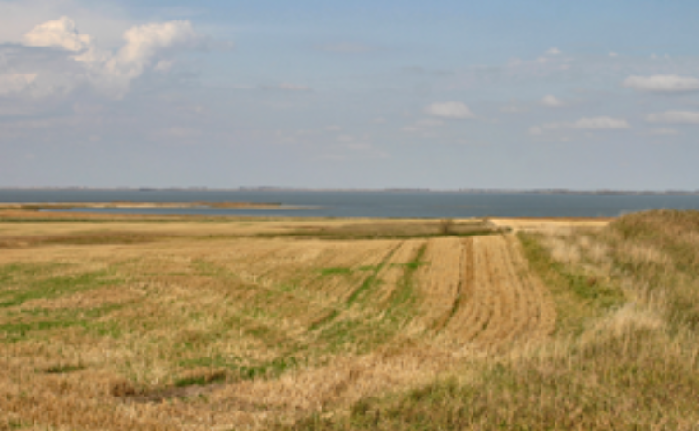

Whitewater Lake from the south

There was a time, before farm lights dotted the night, humans mostly burned wood to keep warm. Folks to the south had lots of wood. Folks to the north, not so much. They worked it out. Northerners waited for me to freeze. They'd hitch horses to a big sleigh, pile in blankets, food and saws – and make a road over my ice. Ah, to hear sleigh bells - creaking runners - and smell wood fires down wind - no matter the direction – these warmed my wintery heart.

Well, I'd better go. Maybe create some waves somewhere. Someday I'd like to chat about Whitewater - the town. Big deal. Really!

David Neufeld adapted ‘Lake to Dust Bowl’ from a story written for Vantage Points 1.

