This story was adapted and aired because of the time we're in; while war is being waged in Ukraine. Please join in reflecting thoughtfully on why and how wars are fought.

Objecting to War

The adults are keeping their heads down. It's quite tense. You see, I was born in Canada, but most everyone older than me escaped New Russia, what later became Ukraine, as refugees. We're still adjusting to English Canada. And likely the English are still uncertain about us.

I'm Anne Heide. Friends call me Noot. It's 1943. I'm 15, living with my family on old #3 between Whitewater and Boissevain. I'm doing Grade 9 correspondence in Strathallan school. Evenings, we gather around the radio to hear news of the war; listening for good news so that our dear Peter can come home!

Many young English men from Boissevain are fighting against the German forces. We Mennonites speak German, which makes it easy to associate us with Canada's enemy. Our religion teaches that we must not do violence to others; that it's wrong to fight in wars; which makes it easy to think we're soft on Hitler. But in reality we reject any authority that uses violence. We're mostly quiet, hard working folks, trying to avoid attention. That's hard, for an outgoing person like me.

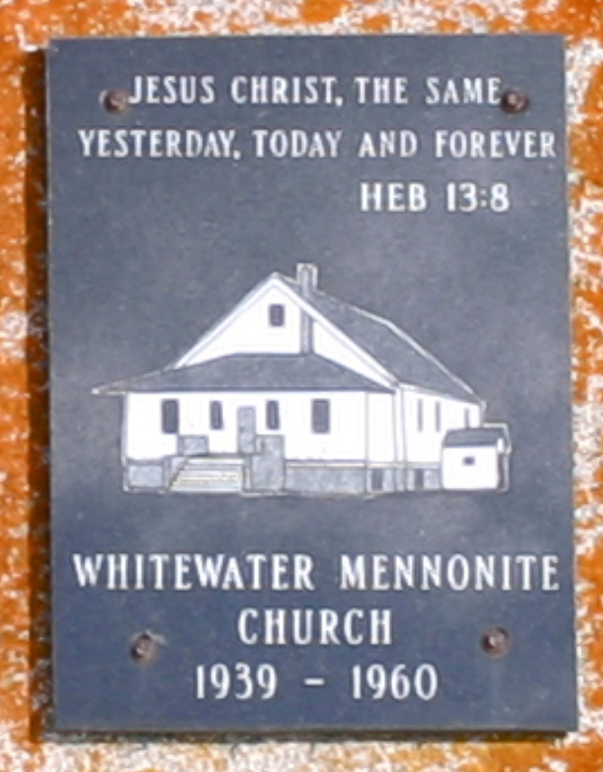

A plaque placed at the Mennonite Cemetery commemorates the Whitewater Mennonite Church.
Fortunately Canada allows my oldest brothers to serve Canada while farming. Soldiers need food too. When Peter applied to stay back as a farmer, he was rejected; saying that father didn't need more help. That was a terrible day for us. The minister encouraged Peter to stay strong in his faith; to apply as a Conscientious Objector. Mennonites, Hutterites and Friends are Peace Churches. Canada allows their members to do alternate service. So Peter applied. And was accepted!

Our Peter was popular, partly because he owned his own car, strange for our community. And now he can't even come home – likely'll be gone 2 full years. He had to go to Duck Mountains to work on a forestry gang.

Mennonites are not of one mind though. Some of our young men joined the forces. Peter Engbrecht became a decorated rear gunner. He was an energetic kid; a hot-shot with his friends, and a crack-shot with a rifle. He wanted badly to join the air force. The church counseled against, but couldn't physically stop him. We've heard that his confident attitude persisted into the war. He was nearly court-marshalled twice, and now is famous for the number of German planes he shot down. Oh my...

The most awkward is when gunner-Peter attends church while on leave, wearing his uniform and jaunty wedge cap, even inside church. Then, with a cigarette and a swagger he attracts our young people to the parking lot, telling them stories. I wonder if those memories will haunt him when he's older.

Yes, it's been tense around here.
“Objecting to War” was inspired by stories I've been told. Stories are everywhere.

David Neufeld

