It's not acceptable these days, I hear, to ask a stranger on the street, “So where do you come from?” and “Why did you choose this place?” But with Mrs. Weightman, it was very hard to resist.

You see, she packed her china and her three teenage kids and left her memories behind in northern Scotland. That was in 1883 or so. And she landed up on a quarter section of flat prairie near Dand – between Deloraine and Hartney.

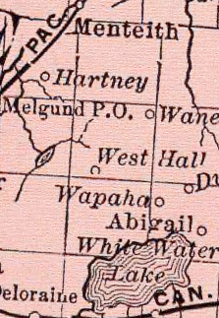

The Weightman home was also the region’s Post Office, named “West Hall” after their home in Scotland.

The family was quite a sight as they trundled out from Brandon on a well rutted trail heading south and west along the Souris River – the Yellow Quill trail we call it. They had bought all they hoped they'd need to make a valient start out there someplace. Horses, plow, seeds, a cow and a tent.

I was going in the same direction. So I sidled up along their creeking hillbilly load and fell into conversation with the boys and Mrs Weightman. Scotland, they tell me, has a few wealthy factory owners and far too many people looking for work - and not enough ways to make a go of it if you're business minded. They'd seen a poster promising free land in Manitoba. So they took the nest egg Mr. Weightman (rest his soul) had squirreled away and took their leave of the Scottish hills.

If it's land you want, I told them, you'd better boot it to the Land Titles Office at Deloraine. Land was going quick. I gave the boys directions and they took off running on their surprised, but eager horses. Mrs. Weightman, she seemed a born adventurer, was happy to move along as fast as the cow and swollen creeks would let her. I hung around the edges in case she needed help. She didn't. In a matter of days the relieved and star dazzled family was celebrating their new found home.

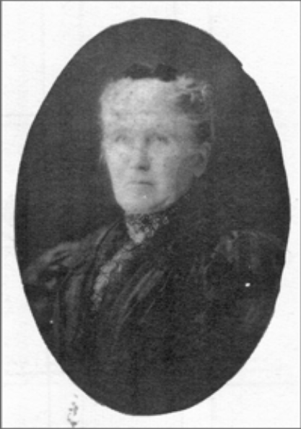

Mrs. E. Weightman

I passed by the Weightman place a few years later. The boys had turned into adequate builders and both were excellent farmers. And the Mrs? She eventually got her farm house, which she immediately turned into a half way house, what you'd call a bed and breakfast, but with dinner and keep for the horses thrown in. Along with most every meal, I heard, she'd start a lively conversation – as every stranger has a story, and every local has a question - “So what brought you here, to this gem of God's creation?”

Adapted by David Neufeld from a story in Vantage Points 4.

