I like my shirts crisp and white. It's the public work I do. And Sam never disappoints. We've grown to appreciate each other. Sam Long keeps the folks of Boissevain looking sharp in fresh, clean clothing. He runs a hand-washing laundry business. Has been here since 1891. I look good for every meeting I attend.
I'm Richard Gardiner Willis, Reeve of the Municipality of Morton. Been Reeve for a dozen years – even tried my hand as Mayor of Boissevain. This year I’ve taken on President of the Union of Manitoba Municipalities. Keeps me busy, but it’s important, and I enjoy it.
I must say, as much work as it is serving our local government, I don’t know Manyy Chinese men cam to Canada to workanyone who works harder than Sam Long in his laundry shop.
The life of a laundryman is grueling and monotonous. Sam spends long days washing, ironing, packaging and delivering clothes – with, I'm sorry to say, very low income.
Soon after he arrived, I asked him why he set up shop in Boissevain. He came to Canada as a teenager, he said, with thousands of Chinese men to build the Canadian Pacific Railway - through the mountains of BC. He was paid $1 a day. It was dangerous work. Sam described how Chinese workers were given the most risky work, like handling explosive nitroglycerin to break up rock. His intelligent, cheerful way impressed me. In a different time, he'd be sitting with me at the council table!
After the railway was finished in 1885, Sam wanted to bring his family to Canada, but the Canadian government discouraged immigration from China, Japan and India by putting a $50 tax on immigrants. By the year 1900, that head tax was $100, and then three years later - $500!
Sam said $500 was two years wages for a Chinese laborer in Canada. There was no way he could bring his entire family to Canada. I wonder if I'd have been as resilient – as resourceful and patient with a country that lacked appreciation for what I offered.
Sam told me of the many Chinese people who headed to the prairies to set up laundry businesses and restaurants in emerging railway towns. Summers were hot and those first winters – he chuckled - extremely cold! Yet Sam persevered – even without nearby family and friends.
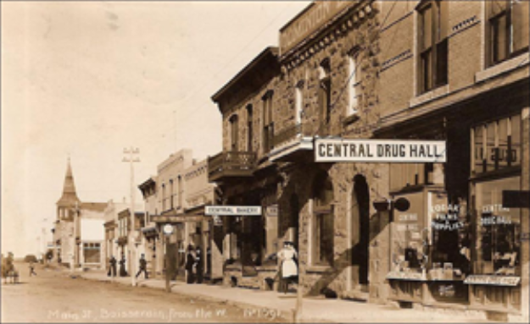
A busy street in Boissevain
He learned English so he could make friends in the area but has little time to socialize. That’s why I collect my shirts in person, so we can chat. He brightens up my day. I hope I do the same for him.
Betty Sawatzky and David Neufeld adapted ‘Sam Long the Laundry Man’ from a story written for Vantage Points 2.

